Register No: **1518102066**

Exercise No: **2**

Date: **15.10.2020**

**Aim:**

To print the count number x in a given list of numbers .

**Program:**

def count(lst,x):

count = 0

for ele in lst:

if ele == x :

count=count+1

print(count)

lst =[]

n = int(input())

for i in range (0,n):

ele = int(input())

lst.append (ele)

x = int(input ())

count(lst,x)

**Link:**

<http://103.53.53.18/mod/vpl/forms/submissionview.php?id=230&userid=1681>

**Output:**

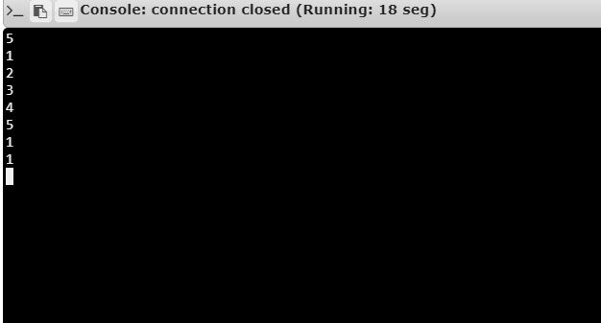

**Result:**

Thus , the code has been executed successfully and the output is verified.